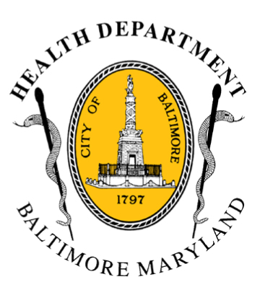
BCHD PRESS RELEASE
Baltimore City Health Department
1001 E. Fayette Street • Baltimore, Maryland 21202
Stephanie Rawlings-Blake, Mayor
Leana Wen, M.D., Commissioner of Health

FOR IMMEDIATE RELEASE

Media Contact: Michael Schwartzberg, PIO
O: (443) 984-2623 C: (443) 462-7939 E: michael.schwartzberg@baltimorecity.gov
Mayor Stephanie Rawlings-Blake and Health Commissioner
Dr. Leana Wen Announce Significant Reduction In Teen Pregnancies

BALTIMORE, MD (February 24, 2015) – Today, Mayor Stephanie Rawlings-Blake and Health Commissioner Leana Wen, M.D. joined with youth advocates at the city’s Healthy Teen And Young Adults Clinic to announce a significant reduction in Baltimore’s teen birth rate. The achievement is linked to the implementation of a citywide strategy for reducing teenage pregnancy - UCHOOSE Know What U Want and the city’s Teen Pregnancy Prevention Initiative.

Between 2009 and 2013, the birth rate for teenagers between age 15 and 19 in Baltimore City dropped by 32 percent, which surpasses the 20 percent goal outlined in Healthy Baltimore 2015. The actual number of births between 2009 and 2013 fell 44 percent – there were 1,494 teen births in 2009 and 831 in 2013. (Changes in the overall female teen population in these years accounts for the difference in rate vs. actual births).

“Reducing the teen birth rate has significant implications for our local economy and the education level of our workforce,” said Mayor Rawlings-Blake. “We know that children of teen mothers have more health problems, are more likely to be incarcerated at some time during adolescence, to give birth as a teenager themselves, and face unemployment as a young adult. This accomplishment is great news as we strive to ensure our youth are healthy and well.”

“One of the top priorities in public health is reducing teen pregnancy rates,” said Dr. Wen. “Teen pregnancy and parenting is the number one reason that young women do not complete high school, which often results in persistent poverty and unemployment. We want all young people in our city to have the resources they need to reach their highest potential, to be able to finish school and support their own family when they choose to have children. “

Mayor Rawlings-Blake and Dr. Wen praised the work of the Teen Pregnancy Prevention Initiative (TPPI), created in 2010 by the Baltimore City Health Department and the Family League of Baltimore. One of the Bmore for Healthy Babies priority programs, the goal of the TPPI was, and remains, to reduce teen births in Baltimore City by ensuring that adolescents and young adults have age-appropriate and evidence-based health education, access to appropriate clinical services, and opportunities to engage their communities.
- more-
2-2-2

Two components of the TPPI were highlighted at today’s announcement – the Youth Advisory Council, a group that provides programmatic steering for TPPI messages and participates in leadership, skill-building and outreach activities for youth throughout the city, and Know What U Want: U Choose, a social marketing campaign that provides youth with family planning education to empower them to plan for their futures. (http://knowwhatuwant.org)

Also at today’s announcement were Beraka Bland, age 19, a teen member of the UCHOOSE Youth Advisory Committee (YAC), and Zoë Reznick Gewanter, Program Director, New Lens. Beraka has been an active Youth Advisory Council member since its inception in 2011. Gewanter has served as the arts and media facilitator with the YAC since 2011, encouraging its members to explore barriers and providing support for teens to make informed health choices and share their message with their peers through media production.

Despite the accomplishment announced today, officials acknowledged there is more work to do. Baltimore City has a teen birth rate (43.4/1,000 population of teenage females age 15 - 19) that is more than twice as high as the state of Maryland (19.3/1,000) and nearly twice as high as the national average (26.5/1,000). In 2000, Baltimore’s teen birth rate was 83.3 /1,000.

###

